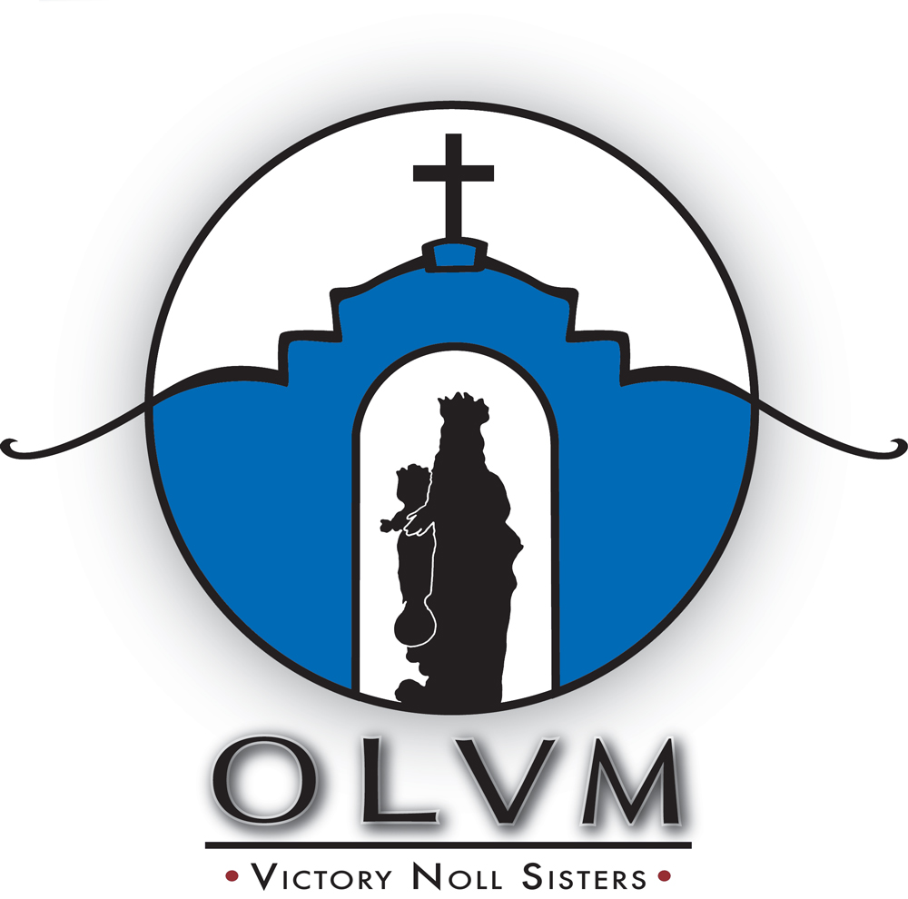

From their founding in 1922 by Father John Joseph Sigstein, Our Lady of Victory Missionary Sisters have been dedicated to living the mission of Jesus. They proclaim the Word of God, foster justice, stand in solidarity with those living in poverty and/or oppression, and promote the development of leaders. The John Joseph Sigstein Foundation has been created to offer grants to organizations that will extend this approach to mission.

Mission Statement

John Joseph Sigstein Foundation (JJSF) is established to promote and sustain the mission of God according to the charism of Our Lady of Victory Missionary Sisters in solidarity with all persons, especially those living in poverty and/or oppression.
Grant Eligibility

The Foundation will consider requests for programs that promote justice for those living in poverty and/or oppression, empower persons to contribute to a more just and peaceful society, contribute to the well-being of the family, and protect and sustain the environment – God’s creation. Catechetical formation programs will also be considered.
The Foundation is looking for programs that offer systemic change and will commit support on an annual basis only. Additional support would be contingent upon program performance and re-application for funds.
Grant applications will not be accepted for building projects, medical programs, political activities, elimination of deficits, individuals, scholarships, foreign organizations, projects already completed, or organizations that are already well-funded.
The John Joseph Sigstein Foundation shares the values of its sponsor, Our Lady of Victory Missionary Sisters.
Each application that is received will be judged on its own merits in conjunction with other applications submitted during the grant cycle. The granting of awards is subject to the resource limitations of the Foundation and the discretion of the board.
Applicants should be not-for-profit entities classified as 501(c)3, or equivalent status, by the Internal Revenue Service.

Grant Application Deadline

JULY 1, 2020

- Grant requests up to $25,000 will be considered.
- Grant recipients will be notified in October. Grant funds will be distributed in November to recipients contingent upon receipt of a signed acceptance agreement.
- The John Joseph Sigstein Foundation reserves the right to conduct an on-site visit of any organization that receives grant funding.
- Electronic submission is preferred.
- Please email completed application and attachments to: jjsfoundation@olvm.org

GRANT APPLICATION
General Information
Name of Organization:
Address:
City: State: Zip Code
Contact Person: Title:
Telephone: E-mail:
Website: Fed. Tax I.D. #:
Executive Director Name:
Signature:
General Requirements
- Purpose of the grant — in one sentence

- Total program cost: Amount requested:
- Estimated number of individuals to be served or impacted by the program:
- Percent of low income/poor served by the program:
- Criteria used to identify “low income”:

- How did you learn of this grant opportunity?:
Proposal Narrative
- Concise overview of your organization’s history, mission, staffing, and programs.
Specify if the application is for a new program or to provide support for an existing program.
New Program? Yes _____ No ______

- Description of issue/activity to be addressed, including the target population or target activity

- How is your agency positioned to address this issue? What is unique in your approach?

- Expected outcome of action; list goals and objectives for the program and give specific measurable criteria
and timeline for successful completion.

- Expected long-term impact

- How will you determine success of action? What will be the measurable criteria for each objective?

- Proposed itemized program budget, with supportive narrative

- How will you fund this program if you are not selected to receive a grant?

General Attachments
Please include the requested documents in separate attachments.
- Current copy of 501(c)3 IRS non-profit letter, or equivalent proof of non-profit status
- List of board members, how often the board meets and if minutes are kept
- If proposal is for funding of a position, include proposed job description
- A progress report of any active grants and/or final report on any recently completed grants funded by this Foundation (if not already submitted)
- Two letters of support
Financial Attachments

Please include the requested documents in separate attachments.
- Current 990 filed with IRS (including schedule B). If not required to file, then submit narrative as to why
- Most recent audit with management letter, if you do not have an audit please explain board’s expertise and procedures to ensure solid financial standing
- Current year’s operating budget with revenues and expenses
- Previous year’s budget versus actual revenue and expenses
Submission
Electronic submission is preferred.
Please email completed application and attachments to: jjsfoundation@olvm.org
Application deadline is July 1, 2020. Applications received after that date will not be considered under the current funding cycle.
Grant requests up to $25,000 will be considered.
Grant recipients will be notified in October. Grant funds will be distributed in November to recipients contingent upon receipt of a signed acceptance agreement.
The John Joseph Sigstein Foundation reserves the right to conduct an on-site visit of any organization that receives grant funding.

